To Lucy Taylor
Ealing Council
Shareholder Representative for Greener Ealing

9 September 2022

Re: Greener Ealing Ltd Annual General Meeting

Dear Lucy

Please find attached the Notice to the second Greener Ealing AGM, to be held on 27 September 2022.

We look forward to welcoming you to the meeting.

Yours sincerely,

Mike Boult
Chairman

GREENER EALING LIMITED
Company Number:12136927

NOTICE IS HEREBY GIVEN that the second annual general meeting of the company will be held at Perceval House, 14-16 Uxbridge Rd, Ealing, London, W5 2HL (and via Microsoft Teams) on 27 September 2022 at 1.00pm for the following purposes:

- To receive the Directors Report and Statutory Report of the Company for the year ended 31 March 2022. (To follow).
- Any Other Business as may be raised at the meeting.

 | 09/09/2022 |  | BY ORDER OF THE BOARD
 | Registered office:
 | Perceval House, 14-16 Uxbridge Rd, Ealing, London, W5 2HL |  | 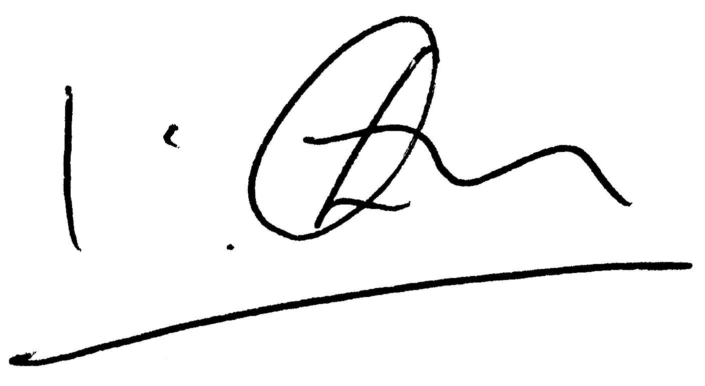
________________________________
WATERSTONE COMPANY SECRETARIES LTD

Notes
As a non-natural person the Council as sole member has appointed Lucy Taylor (so appointed at the Council Cabinet Meeting on 16.06.2021 until further notice) as Representative to act on its behalf at the meeting.
A Member that is entitled to attend and vote at the meeting is entitled to appoint a proxy to attend and vote in his place. Such proxy need not be a member of the Company. If the Council wishes to appoint a proxy, please contact the Company Secretary. (NB as the Council has appointed a Representative it is unlikely that a proxy would be appointed.)

